UNIdecod : tutorial

* Step 1 : Run the app

Just run the application from Matlab.

* 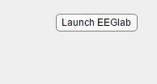Step 2 : Launch EEGLAB

There is a dedicated button on top right of the interface. Once EEGLAB has been launched once, you don’t need to launch it again for further decodings, as long as Matlab is running.

* 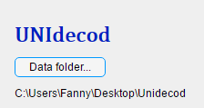Step 3 : Select your data files

Click on ‘Data folder’ to open a window in which you can select the folder containing your .set and .fdt files.

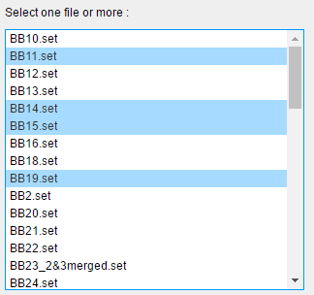

If you get :

Error using matlab.ui.control.internal.model.AbstractStateComponent/set.Items (line 163)

'Items' must be a cell array of character vectors.

Error in UNIdecod_with_function_temp/LoadFolderButtonPushed (line 978)

app.ListBox.Items = app.file_list;

Error using matlab.ui.control.internal.controller.ComponentController/executeUserCallback (line 310)

Error while evaluating Button PrivateButtonPushedFcn.

It means that there is not such file type in the selected directory.

----

Once the folder is opened, you can select one or more data files to analyse together. Press CTRL while clicking on filenames to select multiple data files.

* Step 4 : Select your decoding parameters

You can select your time window, step, conditions to analyse and channels to ignore.

IMPORTANT : Generalization features should be added to the script to be able to use this parameter.

* Step 5 : Select your decoding algorithm

So far, you can chose between :

SVM (JRK) : Sector Vector Machine script by Jean-Remi King ([jeanremi.king@gmail.com](mailto:jeanremi.king@gmail.com))

Riemaniann algorithms by Fosca Al Roumi ([fosca.al.roumi@googlemail.com](mailto:fosca.al.roumi@googlemail.com))

* Step 6 : GO !

Questions ? contact me at [fanny.roussel@cri-paris.org](mailto:fanny.roussel@cri-paris.org)